**XBee Research**

Pin Descriptions

* DOUT and DIN are serial transmit and receive via UART
* CTS: Signals when the DIN buffer halfway full
  + Buffer size = 34 bytes
* RTS: Signals when the DOUT buffer is full (unclear. Halfway? Buffer size?)
* Sleep: Activates/Deactivates sleep mode
* I/O: There are several pins on the XBee that seem to be other sources of data
  + Built-In A/D converter. I/O pins can be analog (input only)
  + Also can be configured for digital input/output
* Vref: This pin is used as a reference for the ADC
* Status: Indicates the mode of operation (I think)
* RF_Tx: ?????

Notes

* XBee Pro = Xbee Series 2
* Minimum connections for functionality
  + VCC, GND, DIN, DOUT
* System idles when no data is being transmitted or received
* UART protocol (taken from datasheet):

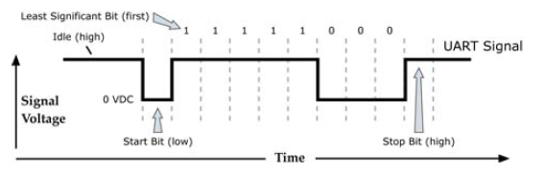

* There are four types of serial Addressing modes.
  + The main difference is the size of data packets
  + Every addressing mode has a Source and Destination field for device addresses
* In Command Mode, serial data from DIN is interpreted as instructions. There are many and they are all detailed in the datasheet.